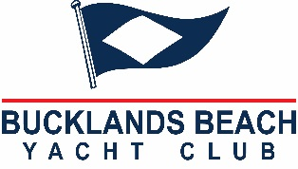 | CENTREBOARD DIVISION  CLASSES  Optimist – Open, Green &  Starling, O’pen Skiff,  RS Feva & 420 | Bucklands Beach Yacht Club  21 Ara Tai  Half Moon Bay  P O Box 54005  Bucklands Beach  Auckland, New Zealand  Telephone: 09 534 3046  Email: coach@bbyc.org.nz

REGISTRATION FORM 2023 -2024 SEASON

Sailors Boat
Name: Class

Sail No: Boat Name:

Address:

Phone: (home) ___________________ (Mobile) _________________________

Email Second email

MEMBERSHIP OF BBYC (please tick appropriate category)
Current BBYC Family Member No. __________ $ N/C
BBYC Family Membership $400.00 (IF NOT ALREADY PAID) $_______________
BBYC Junior Membership $105.00 (IF NOT ALREADY PAID) $_______________

CENTERBOARD SAILING FEES: *$170.00 (1ST SAILOR)
*$140.00 (2ND SAILOR)
*$ 120.00 (3RD SAILOR) $

Total $
Cadet Sailing Fess Per Sunday Series: TBA
Centreboard Coaching after School Tuesday/Wednesday: $12.50 per 2-hour session
RS Feva/420 Coaching: $37.50 per 3–4-hour session
(Note these are subject to numbers of minimum 4 per class, will be invoiced monthly)

PARENT/GUARDIAN DETAILS (junior and youth classes)

Parent/Guardian Name: __________________________________________

Parent/Guardian Signature: _________________________ Date: ___/____/ 2023

Office Use Only

Date Rec’d ___/___/___ Centreboard Fee $

